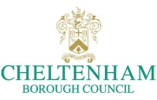 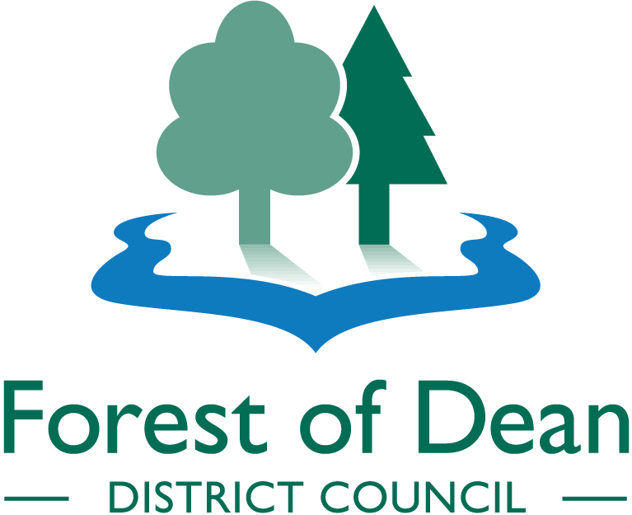 Equality Impact Assessment Guidance and Template February 2017

Equality Impact Assessment

This guidance has been produced to help the service managers undertake equality impact assessments, which will help us find out how the services we deliver affect different groups of people and in what ways. By undertaking an impact assessment, we are able to:
- Take into account the needs, experiences and circumstances of groups of people are affected by our services.
- Identify any inequalities people may experience.
- Think about the other ways in which we can deliver our services which will not lead to inequalities.
- Develop better policy-making, procedures and services.
- Become more accountable to the people that we serve.

The council expects the officer responsible for the service to undertake equality impact assessments themselves. They are completed on any new or amended policies or any changes to service delivery and team structures, that will have a significant impact upon staff or the community. You should never consider doing an Impact Assessment on your own, it is much better to have several people talking through the assessment; more people will bring more thoughts to the table! Remember it should be an integral part of policy development not a last minute thought!

As recent case law as has highlighted, it is very important that EIA’s are completed before decisions are made. Councillors and officers need to have all the information available to consider prior to making decisions, otherwise decisions can be overturned by courts. When writing an important report for Councillors to consider this EIA must accompany that report to raise Councillor awareness of the implications of the decision they are making.

Whilst completing an EIA form you will provide evidence of how you have considered how the ‘protected characteristics’ may be impacted upon by this decision. In line with the General Equality Duty (Equality Act 2010) the Council must, in the exercise of its functions, have due regard for the need to:
- Eliminate discrimination, harassment, victimisation and any other conduct that is prohibited by or under the Equality Act 2010;
- Advance equality of opportunity between persons who share a relevant protected characteristic and persons who do not share it;
- Foster good relations between persons who share a relevant protected characteristic and persons who do not share it
The act specifies a number of groups known as protected characteristics, they are;
- Age
- Disability
- Gender Reassignment
- Race
- Religion or belief
- Gender
- Sexual Orientation
- Marriage and Civil Partnership
- Pregnancy and Maternity

Government guidance also identifies the following groups that commonly experience barriers to participation and should be considered when completing EIAs:
- People with mental health conditions
- People with learning difficulties and disabilities
- Gypsies and travellers
- People undergoing, considering or have undergone gender reassignment
- Asylum seekers
- Refugees
- People with caring responsibilities
- People on low income or benefits
- Staff
Completing the form
The following table will help you decide what information you need to put within each section of the form and what information and evidence you need to gather:

- Persons responsible for this assessment | Details of the person/people completing the assessment – remember this is best done as a group rather than an individual
- Name of the policy, service, strategy, procedure or function:
- Briefly describe it aims and objectives | It will help to ask:  - Why is the policy needed?  - What does the authority hope to achieve by it?  - How will the authority ensure that it works as intended?  - Who are the current customers and impacts on them?  This is not always easy and a discussion will probably be needed between those who define the policy and those who implement it.
- Are there any external considerations? (e.g. Legislation/government directives) | Is the policy/service being changed due to government legislation, budget cuts etc.
- What evidence has helped to inform this assessment? | Identify what evidence is available and set it out here. This includes evidence from involvement and consultation. Identify where there are gaps in the evidence. Include in action plan
- Please specify how intend to gather evidence to fill any gaps identified above: | Provide details where there are gaps in the evidence base and specify the action you intend to take to fill these gaps. For example; What additional involvement and consultation will be needed and how will it be undertaken? Include in action plan.
- Has any consultation been carried out? | Provide details of any consultation that has been undertaken, who this involved and what the outcome was. Have you identified any barriers to your service? Alternatively provide information on any planned consultation.
- What level of impact either directly or indirectly will the proposal have upon the general public / staff? | Consider the level of impact of the policy in respect of the protected characteristics and/or staff to which the policy is relevant.
- Considering the available evidence, what type of impact could this function have on any of the protected characteristics? | Based on the evidence and consultation think about the impact upon each characteristic  - Negative – it could disadvantage and therefore potentially not meet the General Equality duty;  - Positive – it could benefit and help meet the General Equality duty;  - Neutral – neither positive nor negative impact/not sure  Provide reasons behind this impact and mitigating options (include in action plan).
- Action plan | You must monitor implementation of the action plan until all of the actions are complete. It needs to include any action that has been identified – evidence requirements, consultation needed or options for mitigating any impact. What resources are required? Please add additional lines where necessary.
- Is there is anything else that you wish to add? | Use this box to record anything else that you have thought about that you have not recorded anywhere else on the assessment form.
Declaration | Includes sign-off by the responsible officer, line manager and

If you need help at any point or have any questions please contact:
Cheltenham;
Cotswold and West Oxfordshire – corporate.planning@cotswold.gov.uk or 01285 623565
Forest of Dean; Corporate Support Team – corporatesupport@fdean.gov.uk or 01594 812607

Equality Impact Assessment Form

Persons responsible for this assessment:
Names: Mike Clark (Cotswold DC)
Date of assessment:  March 2017 | Telephone: 01285 623565  Email: mike.clark@cotswold.gov.uk

Name of the policy, service, strategy, procedure or function:
Establishment of a new group of companies, known as Publica Group, to deliver council services

Is this a new or existing one? New

Briefly describe it aims and objectives
Cheltenham Borough and Cotswold, Forest of Dean and West Oxfordshire District Councils agreed, in June 2014, a Vision statement for what was then the 2020 Vision for Joint Working, as follows:
“a number of councils, retaining their independence and identity, but working together and sharing resources to maximise mutual benefit leading to more efficient, effective delivery of local services”.
  - Three of the four partner Councils ( Cotswold District Council, Forest of Dean District Council and West Oxfordshire District Council ) are now establishing three local authority owned companies in April 2017 to employ their staff and provide services for the Councils from autumn 2017. This will enable the Councils to deliver significant financial savings totalling £41m over a 10 year period with annual revenue savings of £5.57m after 5 years. Each Council will continue to commission the outcomes and services they wish from either the companies they own, or other service providers.

Are there any external considerations? (e.g. Legislation/government directives)
Whilst the proposal has been developed by the councils, without any pressure or Government directive or legislation requiring this approach, ongoing reductions in Government funding mean that there is a need to respond to long-term financial pressures on the four councils. Even without the current financial pressures, there is a need to continue to find ways of delivering value for money and increase the resilience of each council. Further, more depth in strategic capacity is needed to support the drive towards service improvement and wider social and economic benefits in each locality.

What evidence has helped to inform this assessment?
Source |  | If ticked please explain what
Demographic data and other statistics, including census findings
Recent research findings including studies of deprivation
Results of recent consultations and surveys |  | Outline of results is given below in Question 7
Results of ethnic monitoring data and any equalities data
Anecdotal information from groups and agencies within Gloucestershire/Oxfordshire
Comparisons between similar functions / policies elsewhere
Analysis of audit reports and reviews
Other:

Please specify how intend to gather evidence to fill any gaps identified above:

Has any consultation been carried out?
Yes. Public consultation was carried out by the councils in December 2016/January 2017, through the councils’ websites.
In summary the responses were:

Cotswold - No responses

Forest of Dean - 1 response (which was in favour of the proposal)

West Oxfordshire - 92 responses in total. Broadly in favour: 35 (38%); Broadly against: 28 (30%). The remainder expressed a variety of views, which were neither for nor against and some of which did not relate to the proposal at all.

Staff have been engaged in the proposal as it has developed through briefing sessions, team briefing arrangements in each council and information on the 2020 Partnership portal, which is now the home page for the councils’ intranet. Engagement is a key role within the Programme Team which, along with the Heads of Paid Service in the partner councils, is charged with keeping staff informed and gathering feedback. Staff have been involved in engagement sessions recently on organisation design employee benefits and other issues. Staff engagement will continue as the project develops.

If NO please outline any planned activities

What level of impact either directly or indirectly will the proposal have upon the general public / staff? (Please quantify where possible)
Level of impact | Response
NO IMPACT – The proposal has no impact upon the general public/staff | (public)
LOW – Few members of the general public/staff will be affected by this proposal
MEDIUM – A large group of the general public/staff will be affected by this proposal | (staff)
HIGH – The proposal will have an impact upon the whole community/all staff
Comments: e.g. Who will this specifically impact?

It is not envisaged that this proposal will have any impact on the general public, as it is the intention to continue to deliver the same services as at present to the same (or better) standard. Each council will also continue to have its own branding, website etc.

The proposal will, however, impact on all staff from three of the councils. It is envisaged that all staff from Cotswold, Forest of Dean and West Oxfordshire will be transferred to one of the new companies under a TUPE transfer. (With regard to Cheltenham Borough Council, staff will not be affected as that council will continue to employ their own staff and commission a limited range of services from the group of companies.)

Considering the available evidence, what type of impact could this function have on any of the protected characteristics?
Negative – it could disadvantage and therefore potentially not meet the General Equality duty;
Positive – it could benefit and help meet the General Equality duty;
Neutral – neither positive nor negative impact / Not sure
 | Potential Negative | Potential Positive | Neutral | Reasons | Options for mitigating adverse impacts
Age – Young People |  |  |  | It is not considered that the proposals will result in any changes in services received by the public.
Age – Old People
Disability
Sex – Male
Sex – Female
Race including Gypsy and Travellers
Religion or Belief
Sexual Orientation
Gender Reassignment
Pregnancy and maternity
Geographical impacts on one area
Other Groups
Rural considerations:  ie Access to services; leisure facilities, transport; education; employment; broadband. |  |  |  | It is not considered that the proposals will result in any changes in services received by the public.
Staff  Staff from three councils mentioned above |  |  |  | Staff from Cotswold, Forest of Dean and West Oxfordshire Councils will transfer to the companies in autumn 2017. This is shown as a potential neutral impact for existing staff. It is expected that the transferring Council staff will have statutory protection in accordance with the Transfer of Undertaking Protection Regulations (TUPE). It is expected that length of Service and membership of the Local Government Pension Scheme will be protected for transferring staff. It is expected that there will be no compulsory redundancies upon transfer. In addition the company is consulting existing Council staff on developing a new ‘Total Reward’ approach to employee benefits which will enable employees to have greater choice and flexibility of their personal benefits package in the future. Once staff are employed by the companies, there may subsequently be some changes to the companies’ structure as the business model is developed and implemented. At this time any changes affecting employees will be implemented accordance with requirements of employment law. | Council Staff engagement on potential new organisation design, structure, Total Reward and terms and conditions for the Company will continue. The Council will keep staff informed of the transfer process which will involve staff transferring staff in their current roles. Any re-structuring following the transfer to the companies will be undertaking using a transparent and fair process as required by employment law. It is expected that any redundancies would be kept to a minimum through the use of retraining, redeployment and natural wastage wherever possible.

Action plan (add additional lines if necessary)
Action(s) | Lead Officer | Resource | Timescale
The Council will continue to engage with Trade Unions and Staff as they prepare to transfer out the staff to the new companies. The companies will consult with Council staff on developing new Total Reward approach to employee benefits and any new terms and conditions for company employment. | Deb Bainbridge for 2020 Partnership Councils | Go Shared Services | Autumn 2017
Revise this EIA once the proposed Terms and Conditions are available, to identify any impact upon specific groups of staff. | Mike Clark (Corporate Planning Manager, Cotswold and West Oxon DCs) |  | Autumn 2017

Is there is anything else that you wish to add?

Declaration

I/We are satisfied that an equality impact assessment has been carried out on this policy, service, strategy, procedure or function and where an negative impact has been identified actions have been developed to lessen or negate this impact. We understand that the Equality Impact Assessment is required by the Council and that I/we take responsibility for the completion and quality of this assessment.
Completed By: | Mike Clark |  | Role: | Corporate Planning Manager | Date: | 12th April 2017
Line Managers signature: |  |  |  |  | Date:
Reviewed by Corporate Equality Officer Group (Forest Only): |  |  |  |  | Date:

Please forward an electronic copy to;
Cheltenham;
Cotswold and West Oxfordshire – corporate.planning@cotswold.gov.uk
Forest of Dean; Corporate Support Team – corporatesupport@fdean.gov.uk.

